**501-01 : Advance Web Designing**

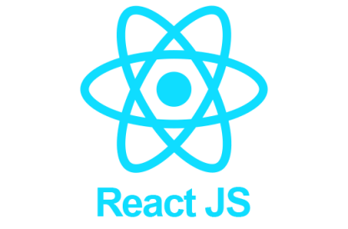**Unit-2: Fundamentals of React.js**

2.1 Overview of React

2.1.1 Concepts of React.

2.1.2 Using React with HTML

2.1.3 React Interactive components: Components within components and Files

2.1.4 Passing data through Props

2.2 Class components

2.2.1 React class and class components

2.2.2 Conditional statements, Operators, Lists

2.2.3 React Events: Adding events, Passing arguments, Event objects